**Hands On 2: Create Eureka Discovery Server And Register Microservices**

**EurekaDiscoveryServiceApplication.java**

package com.cognizant.eureka_discovery_server;  
  
import org.springframework.boot.SpringApplication;  
import org.springframework.boot.autoconfigure.SpringBootApplication;  
import org.springframework.cloud.netflix.eureka.server.EnableEurekaServer;  
  
@SpringBootApplication  
@EnableEurekaServer  
public class EurekaDiscoveryServerApplication {  
  
 public static void main(String[] args) {  
 SpringApplication.run(EurekaDiscoveryServerApplication.class, args);  
 }  
  
}

**application.yml**

server:  
 port: 8761  
  
eureka:  
 client:  
 register-with-eureka: false  
 fetch-registry: false

**GreetController.java**

package com.cognizant.greet.controller;  
  
import org.springframework.web.bind.annotation.GetMapping;  
import org.springframework.web.bind.annotation.RestController;  
  
@RestController  
public class GreetController {  
 @GetMapping("/greet")  
 public String greet() {  
 return "Hello World";  
 }  
}

**GreetApplication.java**

package com.cognizant.greet;  
  
import org.springframework.boot.SpringApplication;  
import org.springframework.boot.autoconfigure.SpringBootApplication;  
import org.springframework.cloud.client.discovery.EnableDiscoveryClient;  
  
@SpringBootApplication  
@EnableDiscoveryClient  
public class GreetApplication {  
  
 public static void main(String[] args) {  
 SpringApplication.*run*(GreetApplication.class, args);  
 }  
  
}

**application.properties**

spring.application.name=greet  
server.port=8083  
  
eureka.client.service-url.defaultZone=http://localhost:8761/eureka/

**AccountController.java**

package com.cognizant.account.controller;  
  
import org.springframework.web.bind.annotation.*;  
  
import java.util.Map;  
  
@RestController  
@RequestMapping("/accounts")  
public class AccountController {  
  
 @GetMapping("/{number}")  
 public Map<String, Object> getAccountDetails(@PathVariable String number) {  
 return Map.*of*(  
 "number", number,  
 "type", "savings",  
 "balance", 234343  
 );  
 }  
}

**AccountApplication.java**

package com.cognizant.account;  
  
import org.springframework.boot.SpringApplication;  
import org.springframework.boot.autoconfigure.SpringBootApplication;  
  
@SpringBootApplication

@EnableDiscoveryClient  
public class AccountApplication {  
  
 public static void main(String[] args) {  
 SpringApplication.*run*(AccountApplication.class, args);  
 }  
  
}

**application.properties**

spring.application.name=account  
server.port=8083  
  
eureka.client.service-url.defaultZone=http://localhost:8761/eureka/

**LoanController.java**

package com.cognizant.loan.controller;  
  
import org.springframework.web.bind.annotation.*;  
  
import java.util.Map;  
  
@RestController  
@RequestMapping("/loans")  
public class LoanController {  
  
 @GetMapping("/{number}")  
 public Map<String, Object> getLoanDetails(@PathVariable String number) {  
 return Map.*of*(  
 "number", number,  
 "type", "car",  
 "loan", 400000,  
 "emi", 3258,  
 "tenure", 18  
 );  
 }  
}

**LoanApplication.java**

package com.cognizant.loan;  
  
import org.springframework.boot.SpringApplication;  
import org.springframework.boot.autoconfigure.SpringBootApplication;  
  
@SpringBootApplication

@EnableDiscoveryClient  
public class LoanApplication {  
  
 public static void main(String[] args) {  
 SpringApplication.*run*(LoanApplication.class, args);  
 }  
  
}

**application.properties**

spring.application.name=loan  
server.port=8083  
  
eureka.client.service-url.defaultZone=http://localhost:8761/eureka/

**Output**

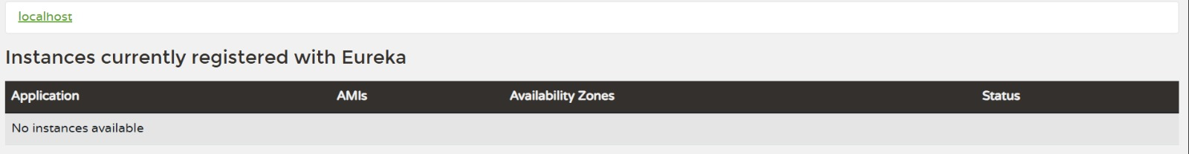

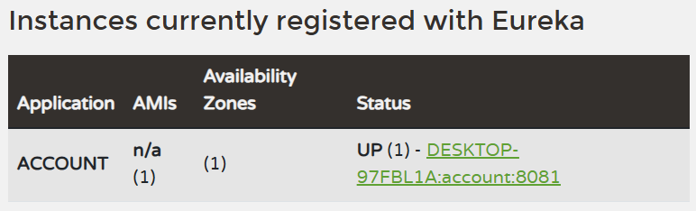

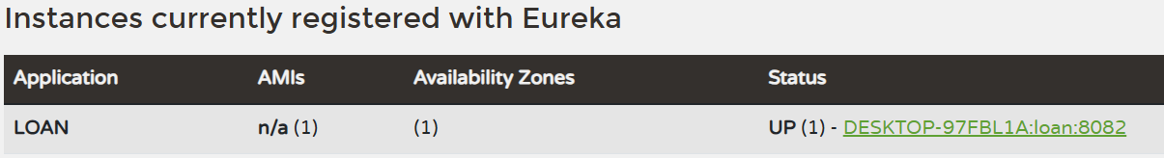

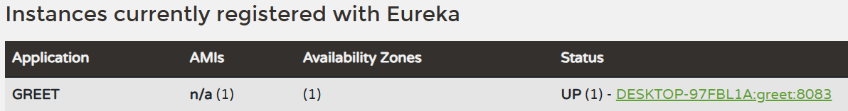

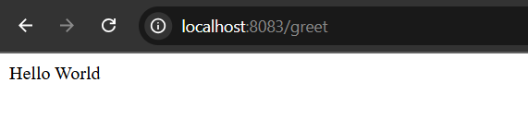

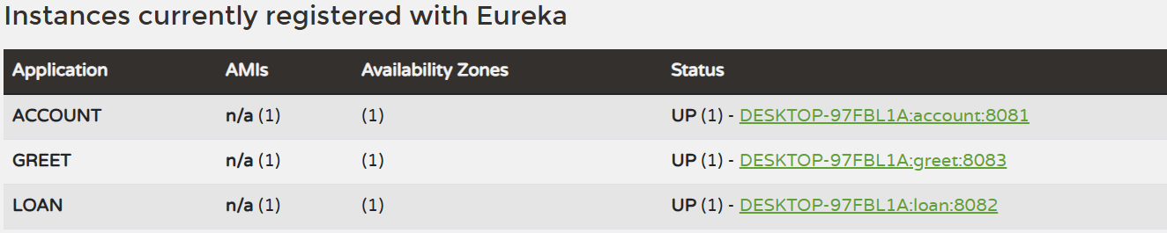

**ApiGatewayApplication.java**

package com.cognizant.api_gateway;  
  
import org.springframework.boot.SpringApplication;  
import org.springframework.boot.autoconfigure.SpringBootApplication;  
  
@SpringBootApplication  
public class ApiGatewayApplication {  
  
 public static void main(String[] args) {  
 SpringApplication.*run*(ApiGatewayApplication.class, args);  
 }  
  
}

**LogFilter.java**

import org.springframework.cloud.gateway.filter.GatewayFilterChain;  
import org.springframework.cloud.gateway.filter.GlobalFilter;  
import org.springframework.core.Ordered;  
import org.springframework.stereotype.Component;  
import org.springframework.web.server.ServerWebExchange;  
import reactor.core.publisher.Mono;  
  
@Component  
public class LogFilter implements GlobalFilter, Ordered {  
  
 @Override  
 public Mono<Void> filter(ServerWebExchange exchange, GatewayFilterChain chain) {  
 System.*out*.println("Incoming request: " + exchange.getRequest().getURI());  
 return chain.filter(exchange);  
 }  
  
 @Override  
 public int getOrder() {  
 return -1;}  
}

**application.properties**

server.port=9090  
spring.application.name=api-gateway  
  
eureka.client.service-url.defaultZone=http://localhost:8761/eureka  
eureka.client.register-with-eureka=true  
eureka.client.fetch-registry=true  
spring.cloud.gateway.discovery.locator.enabled=true  
spring.cloud.gateway.discovery.locator.lower-case-service-id=true

**Output**

